

|  |  |
| --- | --- |
| Project Title | **Credit Card Fraud Detection** |
| language | Machine learning, python, SQL, Excel |
| Tools | VS code, Jupyter notebook |
| Domain | Data Analyst |
| Project Difficulties level | Advance |

Dataset : Dataset is available in the Bhrighu’s case studies repository. You can download it at your convenience.

# About Dataset

## Uber TLC FOIL Response

This directory contains data on over 4.5 million Uber pickups in New York City from April to September 2014, and 14.3 million more Uber pickups from January to June 2015. Trip-level data on 10 other for-hire vehicle (FHV) companies, as well as aggregated data for 329 FHV companies, is also included. All the files are as they were received on August 3, Sept. 15 and Sept. 22, 2015.

FiveThirtyEight obtained the data from the [NYC](http://www.nyc.gov/html/tlc/html/home/home.shtml) [Taxi](http://www.nyc.gov/html/tlc/html/home/home.shtml) [&](http://www.nyc.gov/html/tlc/html/home/home.shtml) [Limousine](http://www.nyc.gov/html/tlc/html/home/home.shtml) [Commission](http://www.nyc.gov/html/tlc/html/home/home.shtml) [(TLC)](http://www.nyc.gov/html/tlc/html/home/home.shtml) by submitting a Freedom of Information Law request on July 20, 2015. The TLC has sent us the data in batches as it continues to review trip data Uber and other HFV companies have submitted to it. The TLC's correspondence with FiveThirtyEight is included in the files TLC_letter.pdf, TLC_letter2.pdf and TLC_letter3.pdf. TLC records requests can be made [here](http://www.nyc.gov/html/tlc/html/passenger/records.shtml).

This data was used for four FiveThirtyEight stories: [Uber](http://fivethirtyeight.com/features/uber-is-serving-new-yorks-outer-boroughs-more-than-taxis-are/) [Is](http://fivethirtyeight.com/features/uber-is-serving-new-yorks-outer-boroughs-more-than-taxis-are/) [Serving](http://fivethirtyeight.com/features/uber-is-serving-new-yorks-outer-boroughs-more-than-taxis-are/) [New](http://fivethirtyeight.com/features/uber-is-serving-new-yorks-outer-boroughs-more-than-taxis-are/) [York’s](http://fivethirtyeight.com/features/uber-is-serving-new-yorks-outer-boroughs-more-than-taxis-are/) [Outer](http://fivethirtyeight.com/features/uber-is-serving-new-yorks-outer-boroughs-more-than-taxis-are/) [Boroughs](http://fivethirtyeight.com/features/uber-is-serving-new-yorks-outer-boroughs-more-than-taxis-are/) [More](http://fivethirtyeight.com/features/uber-is-serving-new-yorks-outer-boroughs-more-than-taxis-are/) [Than](http://fivethirtyeight.com/features/uber-is-serving-new-yorks-outer-boroughs-more-than-taxis-are/) [Taxis Are](http://fivethirtyeight.com/features/uber-is-serving-new-yorks-outer-boroughs-more-than-taxis-are/), [Public](http://fivethirtyeight.com/features/public-transit-should-be-ubers-new-best-friend/) [Transit](http://fivethirtyeight.com/features/public-transit-should-be-ubers-new-best-friend/) [Should](http://fivethirtyeight.com/features/public-transit-should-be-ubers-new-best-friend/) [Be](http://fivethirtyeight.com/features/public-transit-should-be-ubers-new-best-friend/) [Uber’s](http://fivethirtyeight.com/features/public-transit-should-be-ubers-new-best-friend/) [New](http://fivethirtyeight.com/features/public-transit-should-be-ubers-new-best-friend/) [Best](http://fivethirtyeight.com/features/public-transit-should-be-ubers-new-best-friend/) [Friend](http://fivethirtyeight.com/features/public-transit-should-be-ubers-new-best-friend/), [Uber](http://fivethirtyeight.com/features/uber-is-taking-millions-of-manhattan-rides-away-from-taxis/) [Is](http://fivethirtyeight.com/features/uber-is-taking-millions-of-manhattan-rides-away-from-taxis/) [Taking](http://fivethirtyeight.com/features/uber-is-taking-millions-of-manhattan-rides-away-from-taxis/) [Millions](http://fivethirtyeight.com/features/uber-is-taking-millions-of-manhattan-rides-away-from-taxis/) [Of](http://fivethirtyeight.com/features/uber-is-taking-millions-of-manhattan-rides-away-from-taxis/) [Manhattan](http://fivethirtyeight.com/features/uber-is-taking-millions-of-manhattan-rides-away-from-taxis/) [Rides](http://fivethirtyeight.com/features/uber-is-taking-millions-of-manhattan-rides-away-from-taxis/) [Away](http://fivethirtyeight.com/features/uber-is-taking-millions-of-manhattan-rides-away-from-taxis/) [From Taxis](http://fivethirtyeight.com/features/uber-is-taking-millions-of-manhattan-rides-away-from-taxis/), and [Is](http://fivethirtyeight.com/features/is-uber-making-nyc-rush-hour-traffic-worse/) [Uber](http://fivethirtyeight.com/features/is-uber-making-nyc-rush-hour-traffic-worse/) [Making](http://fivethirtyeight.com/features/is-uber-making-nyc-rush-hour-traffic-worse/) [NYC](http://fivethirtyeight.com/features/is-uber-making-nyc-rush-hour-traffic-worse/) [Rush-Hour](http://fivethirtyeight.com/features/is-uber-making-nyc-rush-hour-traffic-worse/) [Traffic](http://fivethirtyeight.com/features/is-uber-making-nyc-rush-hour-traffic-worse/) [Worse?](http://fivethirtyeight.com/features/is-uber-making-nyc-rush-hour-traffic-worse/).

**The Data**

The dataset contains, roughly, four groups of files:

* Uber trip data from 2014 (April - September), separated by month, with detailed location information
* Uber trip data from 2015 (January - June), with less fine-grained location information
* non-Uber FHV (For-Hire Vehicle) trips. The trip information varies by company, but can include day of trip, time of trip, pickup location, driver's for-hire license number, and vehicle's for-hire license number.
* aggregate ride and vehicle statistics for all FHV companies (and, occasionally, for taxi companies)

## Uber trip data from 2014

There are six files of raw data on Uber pickups in New York City from April to September 2014. The files are separated by month and each has the following columns:

* Date/Time : The date and time of the Uber pickup
* Lat : The latitude of the Uber pickup
* Lon : The longitude of the Uber pickup
* Base : The [TLC](http://www.nyc.gov/html/tlc/html/industry/base_and_business.shtml) [base](http://www.nyc.gov/html/tlc/html/industry/base_and_business.shtml) [company](http://www.nyc.gov/html/tlc/html/industry/base_and_business.shtml) code affiliated with the Uber pickup

These files are named:

* uber-raw-data-apr14.csv
* uber-raw-data-aug14.csv
* uber-raw-data-jul14.csv
* uber-raw-data-jun14.csv
* uber-raw-data-may14.csv
* uber-raw-data-sep14.csv

## Uber trip data from 2015

Also included is the file uber-raw-data-janjune-15.csv This file has the following columns:

* Dispatching_base_num : The [TLC](http://www.nyc.gov/html/tlc/html/industry/base_and_business.shtml) [base](http://www.nyc.gov/html/tlc/html/industry/base_and_business.shtml) [company](http://www.nyc.gov/html/tlc/html/industry/base_and_business.shtml) code of the base that dispatched the Uber
* Pickup_date : The date and time of the Uber pickup
* Affiliated_base_num : The [TLC](http://www.nyc.gov/html/tlc/html/industry/base_and_business.shtml) [base](http://www.nyc.gov/html/tlc/html/industry/base_and_business.shtml) [company](http://www.nyc.gov/html/tlc/html/industry/base_and_business.shtml) code affiliated with the Uber pickup
* locationID : The pickup location ID affiliated with the Uber pickup

The Base codes are for the following Uber bases:

B02512 : Unter

B02598 : Hinter

B02617 : Weiter

B02682 : Schmecken

B02764 : Danach-NY

B02765 : Grun

B02835 : Dreist

B02836 : Drinnen

For coarse-grained location information from these pickups, the file taxi-zone-lookup.csv shows the taxi Zone (essentially, neighborhood) and Borough for each locationID.

## Non-Uber FLV trips

The dataset also contains 10 files of raw data on pickups from 10 for-hire vehicle (FHV) companies. The trip information varies by company, but can include day of trip, time of trip, pickup location, driver's for-hire license number, and vehicle's for-hire license number.

These files are named:

* American_B01362.csv
* Diplo_B01196.csv
* Highclass_B01717.csv
* Skyline_B00111.csv
* Carmel_B00256.csv
* Federal_02216.csv
* Lyft_B02510.csv
* Dial7_B00887.csv
* Firstclass_B01536.csv
* Prestige_B01338.csv

## Aggregate Statistics

There is also a file other-FHV-data-jan-aug-2015.csv containing daily pickup data for 329 FHV companies from January 2015 through August 2015.

The file Uber-Jan-Feb-FOIL.csv contains aggregated daily Uber trip statistics in January and February 2015.

## Uber Trip Analysis Machine Learning Project

**Project Overview**

The goal of this project is to analyze Uber trip data to identify patterns and build a predictive model for trip demand. The analysis will cover various aspects such as popular pickup times, busiest days, and fare prediction.

**Dataset**

The dataset used for this project is typically Uber's trip data, which includes details such as:

* **Date/Time:** When the trip started.
* **Lat:** Latitude of the pickup.
* **Lon:** Longitude of the pickup.
* **Base:** TLC base company code affiliated with the Uber pickup.

Uber provides various datasets on platforms like Kaggle, which you can download for analysis.

**Steps and Implementation**

1. **Data Preprocessing**
2. **Exploratory Data Analysis (EDA)**
3. **Feature Engineering**
4. **Model Building**
5. **Model Evaluation**
6. **Visualization**

## Implementation Code

Here is a sample implementation in Python:

|  |
| --- |
| # Importing necessary libraries  import pandas as pd  import numpy as np  import matplotlib.pyplot as plt import seaborn as sns  from sklearn.model_selection import train_test_split from sklearn.ensemble import RandomForestRegressor from sklearn.metrics import mean_squared_error, r2_score  # Load the dataset  data = pd.read_csv('uber-raw-data-apr14.csv')  # Display basic info about the dataset  print(data.info())  # Data Preprocessing  # Convert Date/Time to datetime object  data['Date/Time'] = pd.to_datetime(data['Date/Time'])  # Extracting useful information from Date/Time  data['Hour'] = data['Date/Time'].dt.hour data['Day'] = data['Date/Time'].dt.day  data['DayOfWeek'] = data['Date/Time'].dt.dayofweek data['Month'] = data['Date/Time'].dt.month  # Exploratory Data Analysis  # Plotting the number of trips per hour  plt.figure(figsize=(10,6)) sns.countplot(data['Hour']) plt.title('Trips per Hour') plt.xlabel('Hour of the Day') plt.ylabel('Number of Trips') plt.show()  # Plotting the number of trips per day of the week plt.figure(figsize=(10,6)) sns.countplot(data['DayOfWeek']) plt.title('Trips per Day of the Week') plt.xlabel('Day of the Week') plt.ylabel('Number of Trips') plt.show() |
| # Feature Engineering  # Create dummy variables for categorical features  data = pd.get_dummies(data, columns=['Base'], drop_first=True)  # Define features and target variable  X = data[['Hour', 'Day', 'DayOfWeek', 'Month', 'Lat', 'Lon']]  y = data['Trips'] # Assume we have a 'Trips' column indicating the number of trips  # Split the data into training and testing sets  X_train, X_test, y_train, y_test = train_test_split(X, y, test_size=0.3, random_state=42)  # Model Building  # Train a Random Forest Regressor  rfr = RandomForestRegressor(random_state=42)  rfr.fit(X_train, y_train)  # Predict on the test set y_pred = rfr.predict(X_test)  # Model Evaluation  print("Mean Squared Error:", mean_squared_error(y_test, y_pred)) print("R^2 Score:", r2_score(y_test, y_pred))  # Visualization of Predictions plt.figure(figsize=(10,6))  plt.scatter(y_test, y_pred, alpha=0.3)  plt.xlabel('Actual Trips') plt.ylabel('Predicted Trips') plt.title('Actual vs Predicted Trips') plt.show() |

## Explanation of Code

1. **Data Preprocessing:**
   1. Load the dataset and convert the 'Date/Time' column to a datetime object.

○ Extract useful information like hour, day, day of the week, and month from the 'Date/Time' column.

1. **Exploratory Data Analysis (EDA):**
   1. Visualize the number of trips per hour and per day of the week using count plots.
2. **Feature Engineering:**
   1. Create dummy variables for the categorical feature 'Base'.

○ Define the feature set X and the target variable y.

1. **Model Building:**
   1. Split the data into training and testing sets.

○ Train a Random Forest Regressor on the training data.

○ Predict the number of trips on the test data.

1. **Model Evaluation:**
   1. Evaluate the model using Mean Squared Error (MSE) and R² score.

○ Visualize the actual vs predicted trips to assess model performance.

## Additional Resources

* Uber Trip Data on Kaggle
* Random Forest Regressor Documentation
* Handling DateTime in Pandas

This implementation provides a framework for analyzing and predicting Uber trips. You can extend it by adding more features, trying different models, and improving feature engineering techniques.

## Sample code

Uber Trips Forecasting with XGBoost, Random Forests and

Gradient Boosted Tree Regressors + Ensemble[¶](https://www.kaggle.com/code/jbasurtod/uber-trips-forecasting-using-machine-learning#Uber-Trips-Forecasting-with-XGBoost,-Random-Forests-and-Gradient-Boosted-Tree-Regressors-+-Ensemble)

The

proliferation

of

ride-hailing

services

like

Uber

has

led

to

an

immense

accumulation

of

trip

data,

providing

a

rich

resource

for

predictive

analytics.

Accurate

forecasting

of

Uber

trips

is

critical

for

optimizing

operations,

improving

customer

satisfaction,

and

streamlining

resource

allocation.

This

notebook

aims

to

delve

into

the

predictive

power

of

XGBoost,

Random

Forest

and

Gradient

Boosted

Tree

Regressor

in

forecasting

Uber

trips

using

historical

data

from

2014.

While

there

are

currently

other

state-of-the-art

strategies

to

predict

univariate

time

series,

this

Notebook

intends

to

provide

a

machine

learning

oriented

approach

to

time

series

forecasting

as

an

alternative

tool.

Objectives

The

primary

objectives

of

this

notebook

are:

●

Data

Exploration

and

Preprocessing:

Understand

and

prepare

the

2014

Uber

trip

data

for

model

training.

●

Model

Training:

Train

three

distinct

types

of

models—XGBoost,

GBTR

and

Random

Forests

networks—using

the

2014

data.

●

Model

Evaluation:

Assess

the

performance

of

each

model

using

Mean

Average

Percentage

Error

as

the

main

evaluation

metric.

●

Ensemble

Techniques:

Explore

ensemble

methods

to

combine

the

strengths

of

the

individual

models

and

enhance

forecasting

accuracy.

●

Comparative

Analysis:

Provide

a

comparative

analysis

of

the

forecasting

capabilities

of

the

models

and

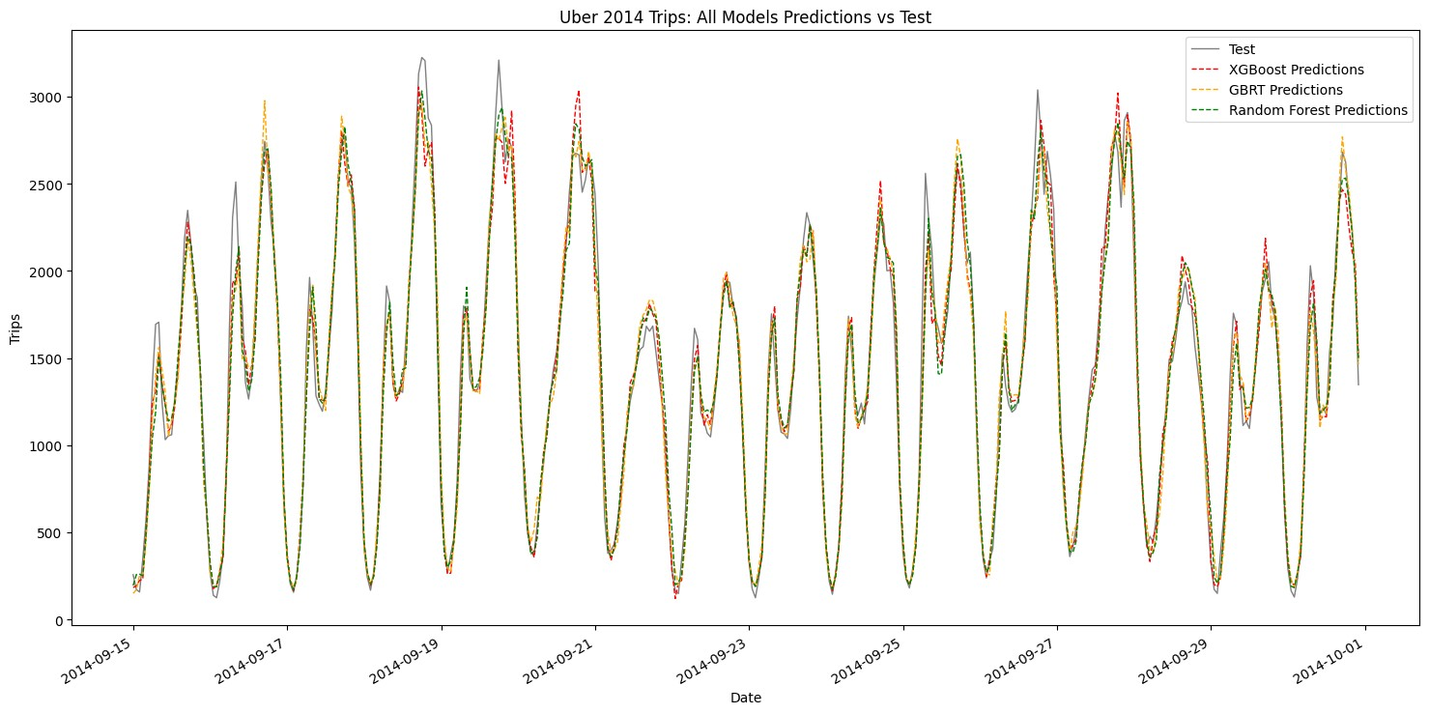

|  |
| --- |
| the ensemble approach.  1. Importing the necessary libraries + useful functions  The first step is to import all necessary libraries and include useful functions to make the code below more readable.  In [1]: import warnings  warnings.filterwarnings("ignore")  import os import numpy as np import pandas as pd import seaborn as sns import xgboost as xgb import matplotlib.pyplot as plt from sklearn.model_selection import KFold from xgboost import plot_importance, plot_tree from sklearn.model_selection import train_test_split from statsmodels.tsa.seasonal import seasonal_decompose from sklearn.metrics import mean_absolute_percentage_error  from sklearn.ensemble import RandomForestRegressor, GradientBoostingRegressor from sklearn.model_selection import GridSearchCV, RandomizedSearchCV, TimeSeriesSplit  In [2]: def PlotDecomposition(result):  plt.figure(figsize=(22,18))  plt.subplot(4,1,1)  plt.plot(result.observed,label='Observed',lw=1) plt.legend(loc='upper left') plt.subplot(4,1,2)  plt.plot(result.trend,label='Trend',lw=1) plt.legend(loc='upper left') plt.subplot(4, 1, 3)  plt.plot(result.seasonal, label='Seasonality',lw=1) plt.legend(loc='upper left') plt.subplot(4, 1, 4)  plt.plot(result.resid, label='Residuals',lw=1) plt.legend(loc='upper left') plt.show()  def CalculateError(pred,sales):  percentual_errors = [] for A_i, B_i **in** zip(sales, pred):  percentual_error = abs((A_i - B_i) / B_i) |

|  |
| --- |
| percentual_errors.append(percentual_error)  return sum(percentual_errors) / len(percentual_errors)  def PlotPredictions(plots,title):  plt.figure(figsize=(18, 8)) for plot **in** plots: plt.plot(plot[0], plot[1], label=plot[2], linestyle=plot[3],  color=plot[4],lw=1) plt.xlabel('Date') plt.ylabel("Trips") plt.title(title) plt.legend()  plt.xticks(rotation=30, ha='right') plt.show()  def create_lagged_features(data, window_size):  X, y = [], []  for i **in** range(len(data) - window_size): X.append(data[i:i+window_size])  y.append(data[i+window_size])  return np.array(X), np.array(y)  2. Reading the Uber Trips Dataset and preparing the data  As you will see, one of the key aspects of this (particluarly important) step is resampling it on an hourly basis. Originally, the data isn't time series prediction ready. Once we finish preparing the data, we will be able to begin training models.  In [3]: files = []  *# Get all uber rides raw data* for dirname, _, filenames **in** os.walk('/kaggle/input'):  for filename **in** filenames:  *#print(os.path.join(dirname, filename))*  files.append(os.path.join(dirname, filename)) if "raw" **in** filename else None  *# Keep the jun - sep 2014 data on a separate list* files = files[:-1]  In [4]:  *# Read and concatenate all CSV files*  dataframes = [pd.read_csv(file) for file **in** files] uber2014 = pd.concat(dataframes, ignore_index=True) |

|  |  |  |  |  |  |  |  |  |
| --- | --- | --- | --- | --- | --- | --- | --- | --- |
| *# Now make sure the date column is set to datetime, sorted and with an adequate name* uber2014['Date/Time'] = pd.to_datetime(uber2014['Date/Time'], format='%m/**%d**/%Y  %H:%M:%S')  uber2014 = uber2014.sort_values(by='Date/Time') uber2014 = uber2014.rename(columns={'Date/Time':'Date'}) uber2014.set_index('Date',inplace=True)  In [5]:  *# Group by hour and count occurrences of 'Base'*  hourly_counts = uber2014['Base'].resample('h').count()  *# Convert the series to a dataframe* uber2014 = hourly_counts.reset_index()  *# Rename columns for clarity* uber2014.columns = ['Date', 'Count'] uber2014.set_index('Date',inplace=True)  In [6]:  uber2014.head()  Out[6]:   |  |  | | --- | --- | |  | Count | | Date |  | | 2014-04-01 00:00:00 | 138 | | 2014-04-01 01:00:00 | 66 | |

|  |  |  |  |  |  |  |
| --- | --- | --- | --- | --- | --- | --- |
| |  |  | | --- | --- | | 2014-04-01 02:00:00 | 53 | | 2014-04-01 03:00:00 | 93 | | 2014-04-01 04:00:00 | 166 |   3. Choosing the optimal train / test sets  In order to choose the correct train / test sets, we need to first visualize the series, then do a seasonal decompose if the trend can inform us of a suggested approach to that split  In [7]: print(uber2014.index.min()) print(uber2014.index.max())  2014-04-01 00:00:00  2014-09-30 22:00:00  In [8]:  *# Let's plot the series* plt.figure(figsize=(20, 8))  plt.plot(uber2014['Count'],linewidth = 1, color='darkslateblue') plt.xticks(rotation=30,ha='right')  plt.show() |

In

[9]:

result

=

seasonal_decompose(uber2014[

'Count'

]

,model

=

'add'

,

period

=

24

*

1

)

PlotDecomposition(result)

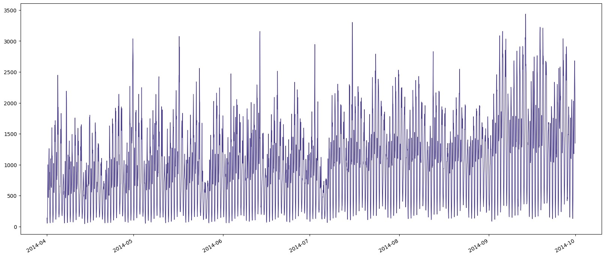

In

[10]:

cutoff_date

=

'2014-09-15

00:00:00

'

plt

.

figure(figsize

=

(

20

,

8

))

plt

.

plot(result

.

trend,linewidth

=

1

,

color

=

'gray'

)

plt

.

axvline(x

=

pd

.

Timestamp(cutoff_date),

color

=

'red'

,

linestyle

=

'--'

,

linewidth

=

1

)

plt

.

xticks(rotation

=

30

,ha

=

'right'

)

plt

.

show()

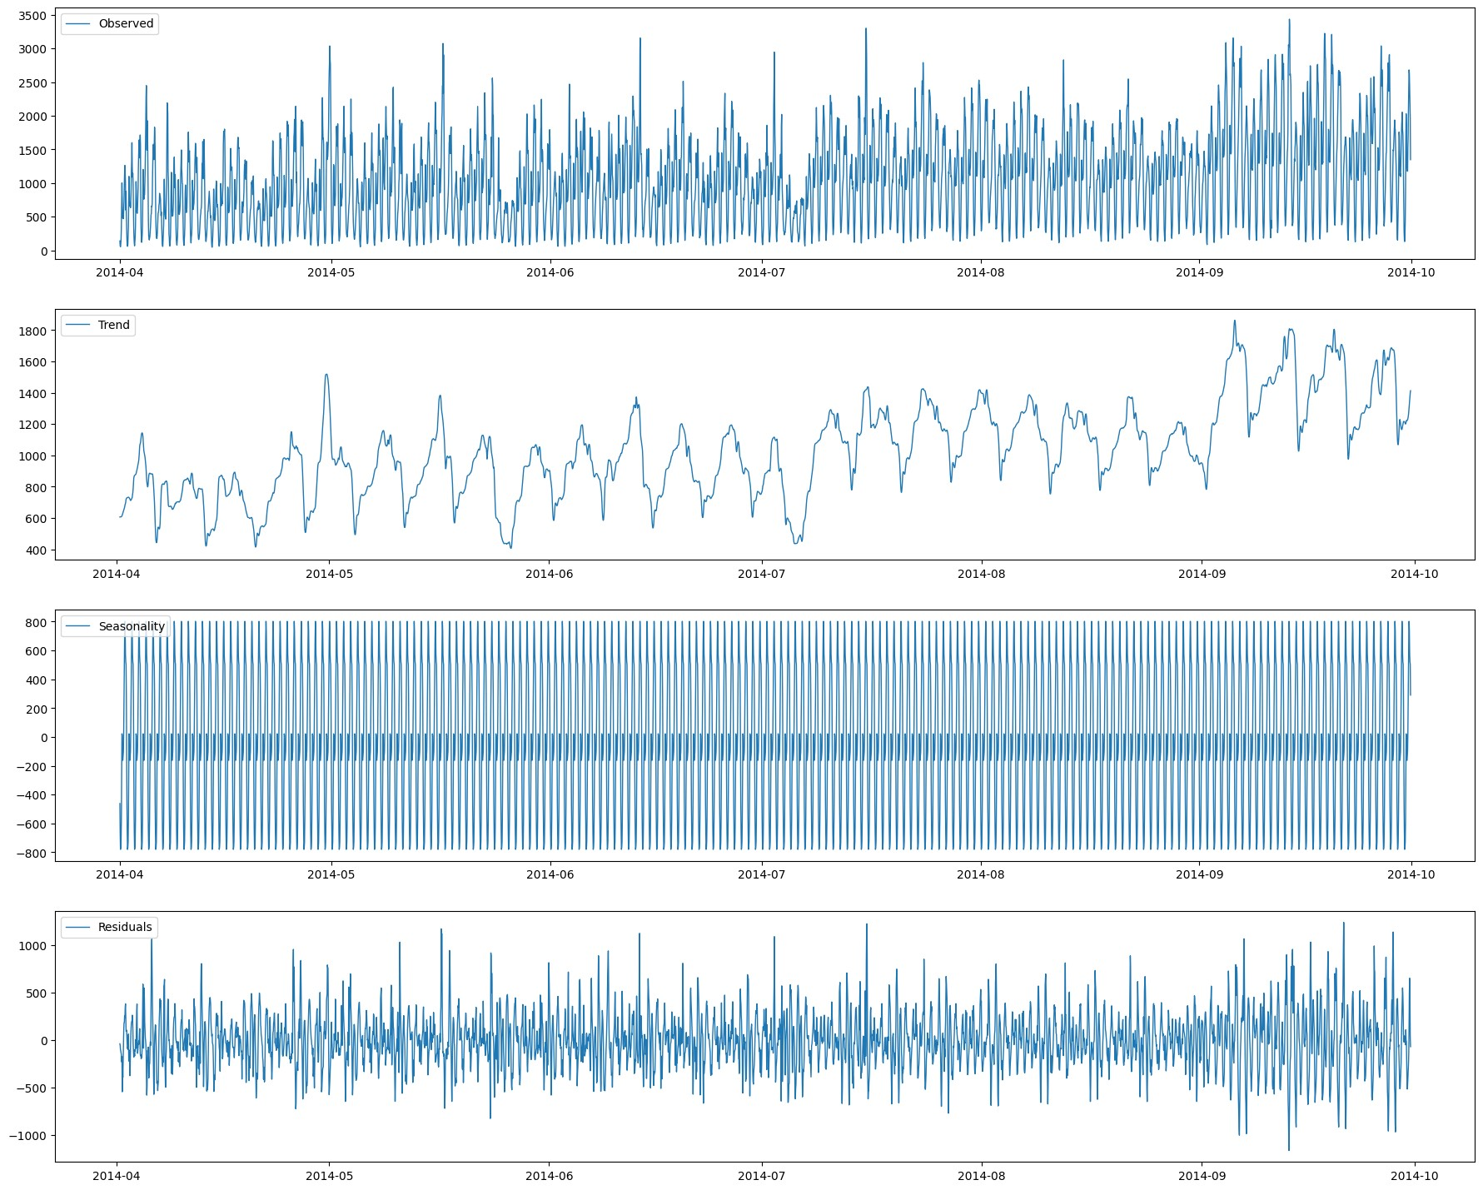

As

seen

above,

the

trend

stays

relatively

stable

until

around

September

2014

,

and

then

increases

to

4

more

peaks.

Leaving

up

to

the

first

2

peaks

as

train

data

and

the

remaining

2

as

test

would

be

sufficient.

This

is

particularly

important,

because

if

we

did

the

usual

80

/

20

split,

we

would

likely

encounter

errors

due

to

the

said

trend

increase.

In

[11]:

uber2014_train

=

uber2014

.

loc[:cutoff_date]

uber2014_test

=

uber2014

.

loc[cutoff_date:]

In

[12]:

uber2014_test

.

rename(columns

=

{

'Count'

:

'TEST

SET'

})

.

join(uber2014_train

.

rename(columns

=

{

'Count'

:

'TRAINING

SET'

})

,

how

=

'outer'

)

.

plot(figsize

=

(

15

,

5

,title

)

=

'Train

/

Test

Sets'

,

style

=

'-'

,lw

=

1

)

Out[12]:

<

Axes

:

title={'center':

'Train

/

Test

Sets'},

xlabel='Date'>

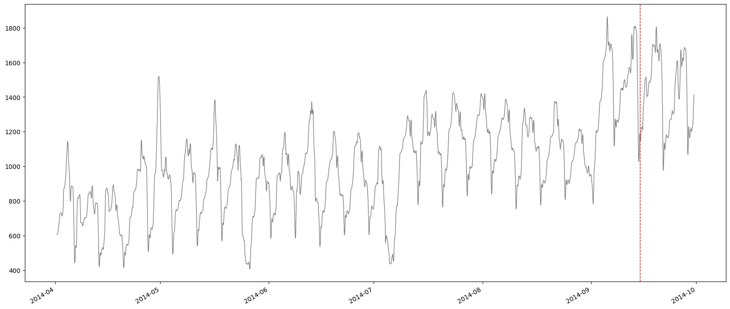

In

[13]:

*#*

*Set*

*the*

*window*

*size*

window_size

=

24

*#*

*Split*

*data*

*into*

*training*

*and*

*test*

*sets*

X_train,

y_train

=

create_lagged_features(uber2014_train[

'Count'

]

.

values,

window_size)

In

[14]:

test_data

=

np

.

concatenate([uber2014_train[

'Count'

]

.

values[

-

window_size:],

uber2014_test[

'Count'

]

.

values])

X_test,

y_test

=

create_lagged_features(test_data,

window_size)

In

[15]:

seed

=

12345

4.

XGBoost

Model

model

XGBoost

is

one

of

the

strongest

ML

algorithms

available.

However,

it

is

usually

prone

to

overfitting.

We

avoid

it

by

doing

Cross

Validation

and

fine

tuning

the

training

process.

In

[16]:

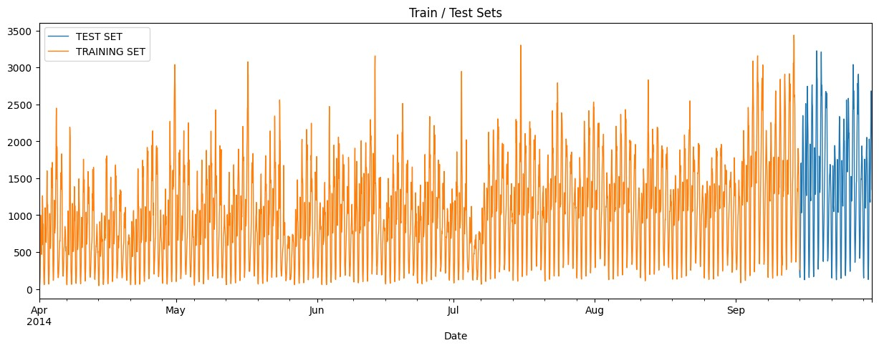

tscv

=

TimeSeriesSplit(n_splits

=

5

)

In

[17]:

xgb_param_grid

=

{

'n_estimators'

:

[

100

,

200

,

300

]

,

'max_depth'

:

[

3

,

6

,

9

,

]

'learning_rate'

:

[

0.01

,

0.1

,

0.3

]

,

'subsample'

:

[

0.6

,

0.8

,

1.0

]

,

'colsample_bytree'

:

[

0.6

,

0.8

,

1.0

]

}

In

[18]:

xgb_model

=

xgb

.

XGBRegressor(objective

=

'reg:squarederror'

,

random_state

=

seed)

In

[19]:

xgb_grid_search

=

GridSearchCV(estimator

=

xgb_model,

param_grid

=

xgb_param_grid,

cv

=

tscv,

scoring

=

'neg_mean_absolute_percentage_error'

,

n_jobs

=-

1

,verbose

=

1

)

xgb_grid_search

.

fit(X_train,

y_train)

Fitting

5

folds

for

each

of

243

candidates,

totalling

1215

fits

Out[19]:

**GridSearchCV**

**estimator:**

**XGBRegressor**

XGBRegressor

In

[20]:

print

(

"Best

XGBoost

parameters:"

,

xgb_grid_search

.

best_params_)

Best

XGBoost

parameters:

{

'colsample_bytree'

:

1.0

,

'learning_rate':

0.1

,

'max_depth':

6

,

'n_estimators':

300

,

'subsample':

0.6}

In

[21]:

xgb_predictions

=

xgb_grid_search

.

best_estimator_

.

predict(X_test)

In

[22]:

PlotPredictions([

(

uber2014_test

.

index,uber2014_test[

'Count'

]

,

'Test'

,

'-'

,

'darkslateblue'

)

,

(

uber2014_test

.

index,xgb_predictions,

'XGBoost

Predictions'

,

'--'

,

'red'

,

)]

'Uber

2014

Trips:

XGBoost

Predictions

vs

Test'

)

In

[23]:

xgb_mape

=

mean_absolute_percentage_error(uber2014_test[

'Count'

]

,

xgb_predictions)

print

(

f

'XGBoost

MAPE:

**\t\t**

**{**

xgb_mape

**:**

.2

%

**}**

'

)

XGBoost

MAPE:

8.37

%

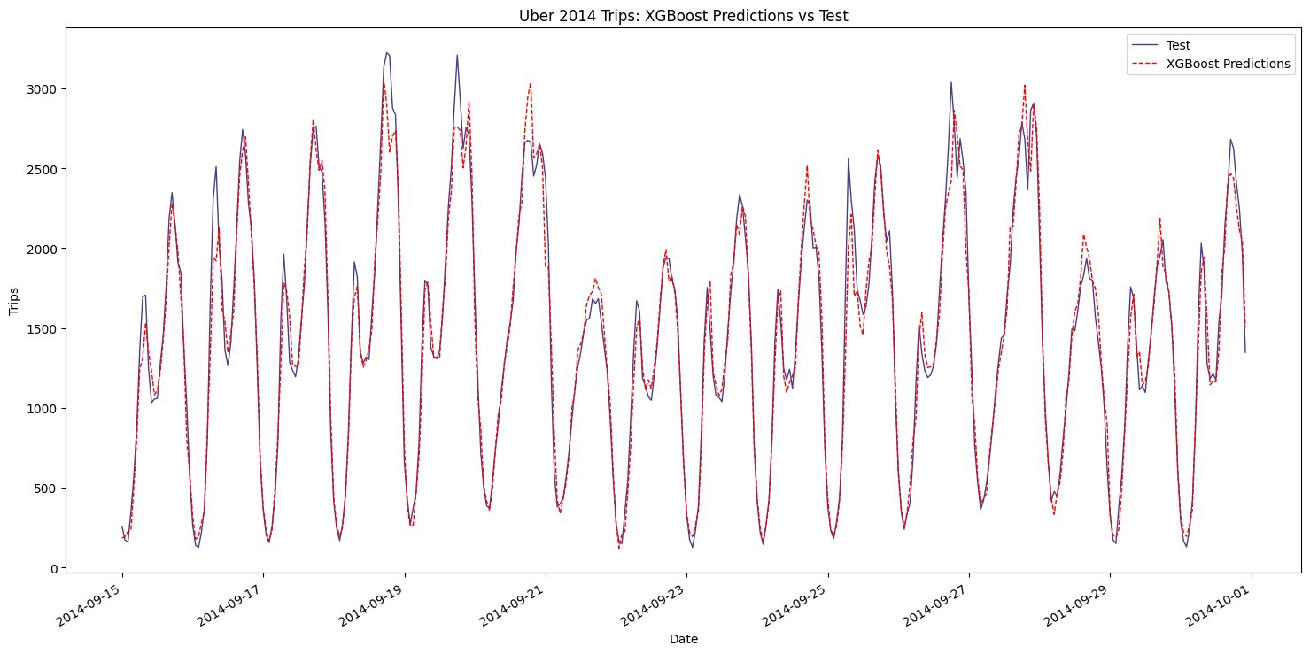

|  |  |
| --- | --- |
| 5. Random Forest model  Finally, Random Forests are less susceptible to overfitting, however (again, in my experience) don't usually perform better than XGB  In [24]: rf_param_grid = {  'n_estimators': [100, 200, 300],  'max_depth': [10, 20, 30],  'min_samples_split': [2, 5, 10],  'min_samples_leaf': [1, 2, 4],  'max_features': [None, 'sqrt', 'log2'] }  In [25]:  rf_model = RandomForestRegressor(random_state=seed)  In [26]: rf_grid_search = GridSearchCV(estimator=rf_model, param_grid=rf_param_grid, cv=tscv, n_jobs=-1, scoring='neg_mean_absolute_percentage_error',verbose = 1) rf_grid_search.fit(X_train, y_train)  Fitting 5 folds for each of 243 candidates, totalling 1215 fits  Out[26]:  **GridSearchCV**  **estimator: RandomForestRegressor**   |  | | --- | | RandomForestRegressor |   In [27]: print("Best Random Forest parameters:", rf_grid_search.best_params_) |

Best

Random

Forest

parameters:

{

'max_depth'

:

30

,

'max_features':

None,

'min_samples_leaf':

2

,

'min_samples_split':

5

,

'n_estimators':

100}

In

[28]:

rf_predictions

=

rf_grid_search

.

best_estimator_

.

predict(X_test)

In

[29]:

PlotPredictions([

(

uber2014_test

.

index,uber2014_test[

'Count'

]

,

'Test'

,

'-'

,

'gray'

)

,

(

uber2014_test

.

index,rf_predictions,

'Random

Forest

Predictions'

,

'--'

,

'green'

)]

,

'Uber

2014

Trips:

Random

Forest

Predictions

vs

Test'

)

In

[30]:

rf_mape

=

mean_absolute_percentage_error(uber2014_test[

'Count'

]

,

rf_predictions)

print

(

f

'Random

Forest

Mean

Percentage

Error:

**\t**

**{**

rf_mape

**:**

.2

%

**}**

'

)

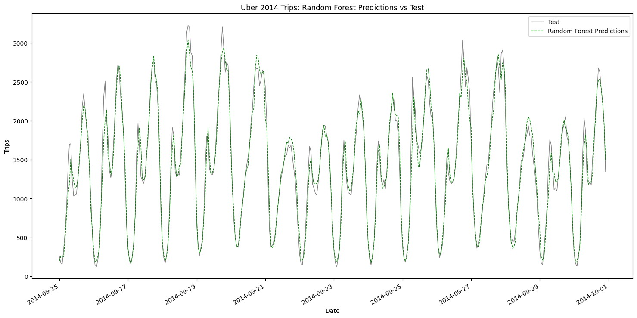

Random

Forest

Mean

Percentage

Error:

9.61

%

6.

Gradient

Boosted

Regression

Tree

model

In

[31]:

gbr_param_grid

=

{

'n_estimators'

:

[

100

,

200

,

300

]

,

'learning_rate'

:

[

0.01

,

0.1

]

,

'max_depth'

:

[

3

,

4

,

5

]

,

'min_samples_split'

:

[

2

,

5

,

10

,

]

'min_samples_leaf'

:

[

1

,

2

,

4

]

,

'max_features'

:

[

'sqrt'

,

'log2'

]

}

In

[32]:

gbr_model

=

GradientBoostingRegressor(random_state

=

seed)

In

[33]:

gbr_grid_search

=

GridSearchCV(estimator

=

gbr_model,

param_grid

=

gbr_param_grid,

cv

=

tscv,

n_jobs

=-

1

,

scoring

=

'neg_mean_absolute_percentage_error'

,verbose

=

1

)

gbr_grid_search

.

fit(X_train,

y_train)

Fitting

5

folds

for

each

of

324

candidates,

totalling

1620

fits

Out[33]:

**GridSearchCV**

**estimator:**

**GradientBoostingRegressor**

GradientBoostingRegressor

In

[34]:

print

(

"Best

Random

Forest

parameters:"

,

gbr_grid_search

.

best_params_)

Best

Random

Forest

parameters:

{

'learning_rate'

:

0.1

,

'max_depth':

5

,

'max_features':

'sqrt',

'min_samples_leaf':

1

,

'min_samples_split':

,

5

'n_estimators':

300}

In

[35]:

gbr_predictions

=

gbr_grid_search

.

best_estimator_

.

predict(X_test)

In

[36]:

PlotPredictions([

(

uber2014_test

.

index,uber2014_test[

'Count'

,

]

'Test'

,

'-'

,

'gray'

)

,

(

uber2014_test

.

index,gbr_predictions,

'GBRT

Predictions'

,

'--'

,

'orange'

)]

,

'Uber

2014

Trips:

GBRT

Predictions

vs

Test'

)

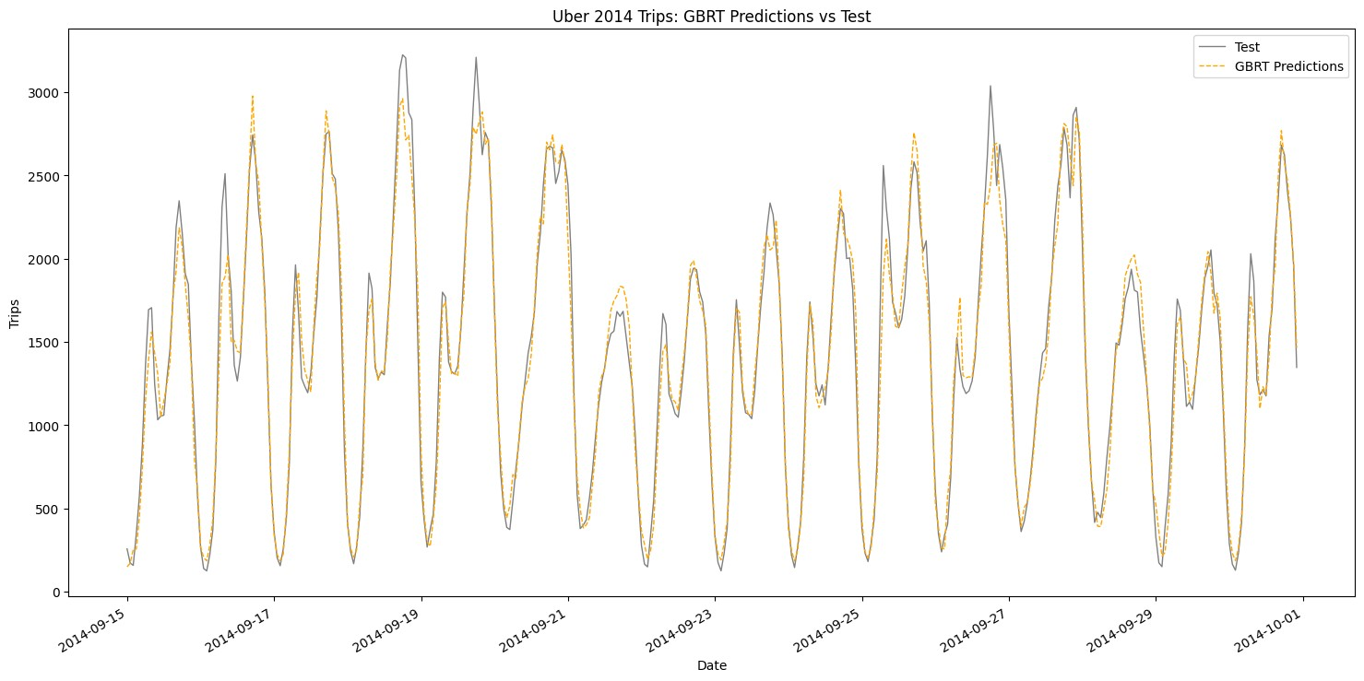

In

[37]:

gbr_mape

=

mean_absolute_percentage_error(y_test,

gbr_predictions)

print

(

f

'GBTR

Percentage

Error:

**\t**

**{**

gbr_mape

**:**

.2

%

**}**

'

)

GBTR

Percentage

Error:

10.02

%

7.

Visualizing

all

models

at

once

In

[38]:

PlotPredictions([

(

uber2014_test

.

index,uber2014_test[

'Count'

]

,

'Test'

,

'-'

,

'gray'

)

,

(

uber2014_test

.

index,xgb_predictions,

'XGBoost

Predictions'

,

'--'

,

'red'

,

)

(

uber2014_test

.

index,gbr_predictions,

'GBRT

Predictions'

,

'--'

,

'orange'

)

,

(

uber2014_test

.

index,rf_predictions,

'Random

Forest

Predictions'

,

'--'

,

'green'

)]

,

'Uber

2014

Trips:

All

Models

Predictions

vs

Test'

)

The

above

plot

shows

how

all

algorithms

have

actually

being

very

close

to

predicting

the

test

set.

Visually,

we

can

safely

assume

that

using

either

algorithm

could

be

a

safe

bet.

The

last

step

is

to

try

an

ensemble

to



|  |
| --- |
| 8. Ensemble  Building the ensemble requires to understand how each algorithm has performed individually first. Then, decide how we can leverage each one's strenghts to our advantage.  In [39]: print(f'XGBoost MAPE:**\t\t\t{**xgb_mape**:**.2%**}**') print(f'Random Forest MAPE:**\t\t{**rf_mape**:**.2%**}**') print(f'GBTR Percentage Error:**\t\t{**gbr_mape**:**.2%**}**')  XGBoost MAPE: 8.37%  Random Forest MAPE: 9.61%  GBTR Percentage Error: 10.02%  **Convert MAPE scores to weights:** Since MAPE is inversely related to model performance, we can use the reciprocal of MAPE as a starting point for determining the weights. Normalize these reciprocals to get the weights.  The ensemble prediction formula can be expressed as follows:  **Reciprocal of XGBoost MAPE =** 1/8.37 ≈ 0.119  **Reciprocal of Random Forest MAPE =** 1/9.61 ≈ 0.104  **Reciprocal of GBTR MAPE =** 1/10.02 ≈ 0.1  After doing the sum of all of them and applying each one's weight, we come up with the following formula:  Ensemble Prediction = 0.368 *XGBoost Prediction + 0.322* Random Forest Prediction + 0.310 * GBTR Prediction  In [40]:  *# Weights* weights = np.array([0.368, 0.322, 0.310])  *# Combine predictions using weighted average*  ensemble_predictions = (weights[0] * xgb_predictions + weights[1] * rf_predictions + weights[2] * gbr_predictions) |

In

[41]:

PlotPredictions([

(

uber2014_test

.

index,uber2014_test[

'Count'

]

,

'Test'

,

'-'

,

'gray'

)

,

(

uber2014_test

.

index,ensemble_predictions,

'Ensemble

Predictions'

,

'--'

,

'purple'

)]

,

'Uber

2014

Trips:

Ensemble

Predictions

vs

Test'

)

In

[42]:

*#*

*Calculate*

*MAPE*

*for*

*ensemble*

*predictions*

*on*

*test*

*set*

ensemble_mape

=

mean_absolute_percentage_error(uber2014_test[

'Count'

]

,

ensemble_predictions)

print

(

f

'Ensemble

MAPE:

**\t**

**{**

ensemble_mape

**:**

.2

%

**}**

'

)

Ensemble

MAPE:

8.60

%

In

[43]:

print

(

f

'XGBoost

MAPE:

**\t\t**

**{**

xgb_mape

**:**

.2

%

**}**

'

)

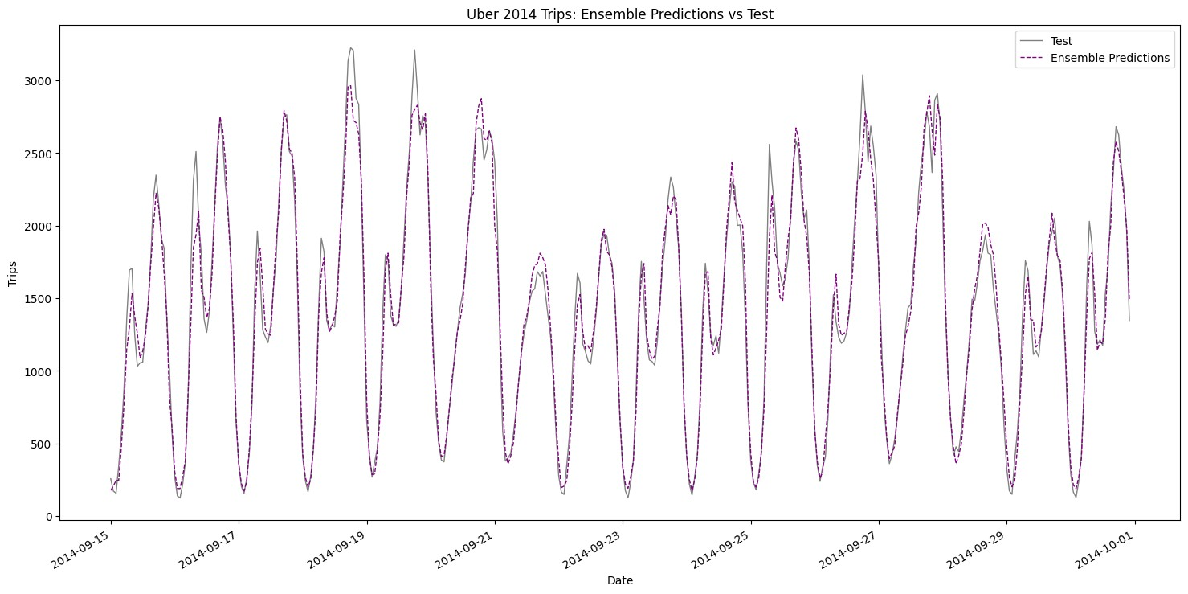

|  |
| --- |
| print(f'Random Forest MAPE:**\t{**rf_mape**:**.2%**}**') print(f'GBTR MAPE:**\t\t{**gbr_mape**:**.2%**}**') print(f'Ensemble MAPE:**\t\t{**ensemble_mape**:**.2%**}**')  XGBoost MAPE: 8.37%  Random Forest MAPE: 9.61%  GBTR MAPE: 10.02%  Ensemble MAPE: 8.60%  linkcode  9. Insights and Conclusions from Training and Evaluation  Model Performance Overview:   * XGBoost: With a MAPE of 8.37%, XGBoost remains the top-performing model, effectively capturing patterns in the Uber Trip 2014 data. Its strong performance highlights its ability to manage complex interactions and temporal dependencies. * Random Forest: Recorded a MAPE of 9.61%, showing good performance. This model effectively utilizes the window-based logic to capture time-dependent variations in the data. * Gradient Boosted Tree Regressor (GBTR): Achieved a MAPE of 10.02%, indicating reasonable performance, although it does not match the effectiveness of XGBoost or Random Forest.   Ensemble Model:   * The ensemble model achieved a MAPE of 8.60%, which is an improvement over both Random Forest and GBTR. This performance showcases the ensemble's ability to integrate the strengths of the individual models while providing robust and stable predictions. * The ensemble combines predictions from XGBoost, Random Forest, and GBTR, capitalizing on the complementary strengths of each model.   Impact of Window-Based Logic:   * Applying window-based logic to model training has effectively captured temporal dependencies in the data, resulting in enhanced predictive accuracy across all models. * This approach ensures that the models can better handle seasonality and trends, which is crucial for accurate time series forecasting, particularly in dynamic contexts like ride-sharing demand. |
| Cross-Validation and Parameter Tuning:   * Cross-validation has provided a reliable assessment of model performance in temporal contexts, ensuring robustness and reducing the risk of overfitting. * Parameter tuning, particularly for XGBoost and GBTR, has likely contributed to their strong performances, reflecting effective optimization efforts.   Practical Implications:   * For practical applications, XGBoost is recommended for scenarios where achieving the lowest error is critical due to its superior MAPE. * The ensemble model serves as a strong alternative, providing improved predictive performance over the individual models, particularly useful for scenarios requiring stability and reliability.   Final Conclusion  The training and evaluation of these models underscore the effectiveness of XGBoost, with its best-in-class MAPE of 8.37%. The ensemble model, achieving a MAPE of 8.60%, effectively combines the strengths of the individual models, resulting in robust and reliable predictions. These findings highlight the importance of considering temporal structures in time series data and lay a strong foundation for future predictive modeling efforts in similar applications. |

[Reference](https://www.kaggle.com/datasets/fivethirtyeight/uber-pickups-in-new-york-city/code) [link](https://www.kaggle.com/datasets/fivethirtyeight/uber-pickups-in-new-york-city/code)